

**TRIBHUVAN UNIVERSITY**

**INSTITUTE OF ENGINEERING**

**PULCHOWK CAMPUS**

A PROJECT REPORT ON COMPUTER GRAPHICS

TITLE**:**

**A Detailed 3D Visualization of Modern Bedroom Design Using OpenGL**

SUBMITTED BY:

**Pradeep Bhattarai(077BCT100)**

SUBMITTED TO:

**DEPARTMENT OF ELECTRONICS AND COMPUTER ENGINEERING**

SUBMITTED ON:

August 19, 2023

**ACKNOWLEDGEMENT**

The planning, designing, and final upshot of this project was made possible by the guidance and assistance of many people to whom we are extremely grateful.

First and foremost, we’d like to express our sincere gratitude toward our lecturer, **Mr. Lok Nath Regmi** (Department of Electronics and Computer Engineering, Pulchowk Campus), for his constant support, guidance, and insightful lectures.

We would also like to thank the Department of Electronics and Computer Engineering, Pulchowk Campus for providing us the opportunity to work on this project which helped us strengthen our concepts of Computer Graphics, understand the workflow of projects, and provided us with an experience of collaboration and teamwork.

**Author:**

Pradeep Bhattarai

**Abstract**

In the modern digital era, 3D visualizations have emerged as pivotal tools in a variety of domains ranging from gaming to architecture. This project aims to harness the capabilities of OpenGL to create a realistic and interactive 3D representation of a bedroom. Using a combination of basic geometric primitives like cubes and pyramids, intricate bedroom elements such as beds, wardrobes, fans, and dressing tables have been crafted. The design embraces a modular approach, where each component of the bedroom is constructed using individual functions, all orchestrated within a central display function. This not only ensures code clarity but also offers scalability for future expansions. The project also offers user interactivity, allowing navigation within the bedroom space and interaction with specific elements like a rotating fan. While the foundational design captures the essence of a bedroom environment, future enhancements can focus on improving realism, integrating textures, dynamic lighting, and introducing more interactive features.

In conclusion, this project stands as a testament to the versatility of OpenGL in crafting detailed and immersive 3D scenes and serves as a platform for further exploration and innovation in the realm of computer graphics.

**TABLE OF CONTENTS**

1 OBJECTIVES ……………………………………………………………… 1

2 INTRODUCTION ………………………………………………………… 2-4

3 APPLICATION …………………………………………………………….. 5

4 LITERATURE SURVEY ……………………………………………………. 6

5 EXISTING SYSTEMS………………………………………………………..7

6 METHODOLOGY ………………………………………………………….. 8

7 IMPLEMENTATION ……………………………………………………….. 9

7.1 BLOCK DIAGRAM ………………………………………………… 10

8 RESULTS ………………………………………………………………… 11

9 PROBLEMS FACED AND SOLUTIONS ………………………………… 12

10 LIMITATIONS AND FUTURE ENHANCEMENTS …………………….. 13

11 CONCLUSION AND RECOMMENDATIONS ………………………….. 14

12 REFERENCES …………………………………………………………… 15

**1.OBJECTIVES**

The main objectives of our project are as follows:

* To design and create an accurate and interactive 3D representation of a bedroom environment using the OpenGL library.
* To transform basic geometric primitives into intricate and realistic bedroom elements such as furniture and decor.
* To adopt a modular approach in the codebase, ensuring clarity, maintainability, and ease of future expansions.
* To provide users with the ability to navigate within the 3D bedroom space and interact with specific elements, enhancing the immersive experience.
* To delve deep into the principles of 3D graphics and leverage various transformations, such as translation, rotation, and scaling, to craft the desired scene.
* To serve as a practical and hands-on example for individuals venturing into the world of computer graphics, elucidating the capabilities and functions of OpenGL.
* To establish a robust foundation for the project, facilitating potential future enhancements in terms of design intricacy, realism, and additional features.

**2. INTRODUCTION**

In the realm of computer graphics, the ability to replicate real-world environments in a virtual space has seen significant advancements. From immersive video games to realistic architectural simulations, 3D visualizations have become a cornerstone in bridging the gap between reality and the digital world. Central to this revolution is OpenGL, a cross-platform, cross-language application programming interface (API) that has facilitated the creation of 2D and 3D graphics in a multitude of applications.

This project, focused on the visualization of a bedroom, is a manifestation of the capabilities of OpenGL. Bedrooms, being integral components of our living spaces, carry unique design elements and personal touches that make them distinct. Capturing the essence of such a personal space in a 3D digital environment presents both challenges and opportunities. Challenges arise in ensuring realism, maintaining proportions, and allowing interactivity. However, the opportunities lie in the potential applications of such visualizations - from aiding interior designers to serving as educational tools for students of computer graphics.

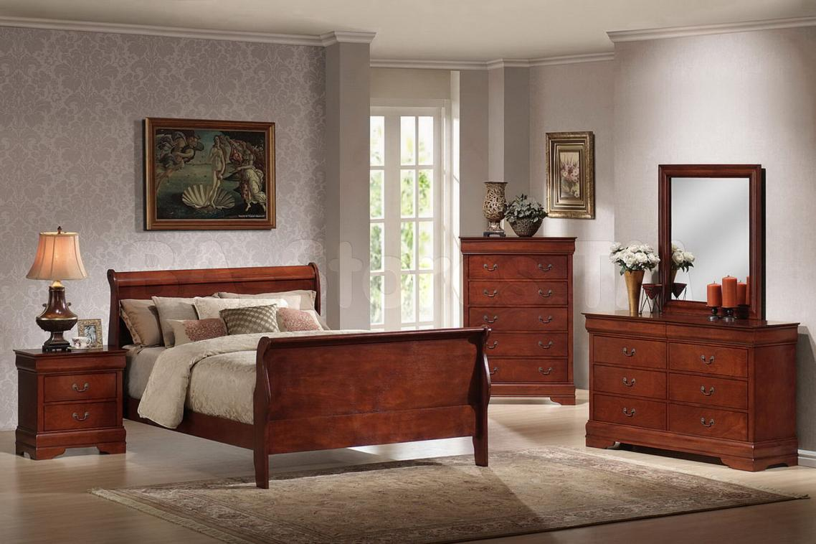

Fig: Bedroom Picture

By leveraging the foundational and advanced features of OpenGL, this project embarks on a journey to create a detailed, interactive, and realistic 3D representation of a bedroom. Through the meticulous positioning, scaling, and rotation of basic geometric primitives, the intricate elements of a bedroom - be it the grandeur of a wardrobe or the simplicity of a bedside lamp - are brought to life. This introduction provides a gateway into the project's intricacies, its objectives, methodology, and the results achieved.

**3. APPLICATION**

The 3D visualization of a bedroom, as developed in this project, finds its relevance and application across several domains:

1. **Interior Design and Architecture:** One of the primary applications of this project lies in the field of interior design. Designers can use such 3D visualizations to showcase potential bedroom layouts and designs to their clients. It provides a virtual canvas where different design elements can be experimented with before finalizing the physical setup.

2. **Educational Tool:** For academic purposes, this project serves as a hands-on example for students studying computer graphics. It offers a practical insight into how OpenGL functions can be utilized to construct a comprehensive 3D scene. Additionally, instructors can use it as a teaching aid to explain various OpenGL concepts, transformations, and rendering techniques.

3. **Virtual Reality (VR) and Augmented Reality (AR):** In the burgeoning field of VR and AR, such 3D models can be integrated to provide immersive experiences. Potential homeowners or renters could take virtual tours of properties, experiencing the space even before they visit in person.

4. **Real Estate Marketing:** Real estate agents and firms can use such visualizations as part of their marketing collateral. A detailed 3D view of a property can provide potential buyers with a clearer understanding of the space, aiding in their decision-making process.

5. **Gaming and Entertainment:** The fundamentals used in creating this bedroom visualization can be adapted and expanded upon in the development of video games or simulation software. Scenes like these can be a part of larger virtual worlds where users can interact and explore.

6. **Furniture Retail:** Retail businesses selling furniture and bedroom accessories can use such models to showcase how their products look in a real-world setting. Customers can virtually place different items in the room, helping them visualize their purchases in their own homes.

In essence, the 3D bedroom visualization project, while focused on a specific environment, opens doors to a myriad of applications across diverse sectors, making it a versatile and valuable tool.

**4. LITERATURE SURVEY**

The domain of 3D visualization, particularly in the context of room and interior design, has been explored extensively in literature, especially with the advent and progression of OpenGL.

- Neider, Jackie, Tom Davis, and Mason Woo. "OpenGL Programming Guide". Addison-Wesley, 1993.

- Bowman, D. et al. "3D User Interfaces: Theory and Practice". Addison Wesley Longman Publishing Co., Inc., 2004.

- Stuerzlinger, W. et al. "The design of 3D user interfaces: Principles and practices". In IEEE Computer Graphics and Applications, 2006.

**5. EXISTING SYSTEMS**

The domain of 3D visualization, especially in the context of interior design and architecture, has seen the emergence of numerous systems and platforms over the years. These systems vary in complexity, user-friendliness, and application.

1. **Blender:** Originally designed as a 3D animation tool, Blender has evolved into a comprehensive 3D modeling and rendering platform. With its open-source nature, Blender offers a wide array of tools for creating detailed 3D scenes, including interiors. Its expansive feature set, however, also comes with a steeper learning curve.

2. **SketchUp:** Tailored for architects and designers, SketchUp is a user-friendly tool for creating architectural visualizations. Its simplicity and intuitive user interface make it a popular choice for professionals looking to quickly draft and visualize architectural designs, including bedroom interiors.

3. **3DS Max:** Developed by Autodesk, 3DS Max is a powerhouse in the world of 3D modeling, animation, and rendering. It offers a plethora of tools and features for creating detailed and realistic 3D scenes. Its integration with other Autodesk products also makes it a favorite among professionals in the design and animation industry.

4. **Unity and Unreal Engine:** While primarily known as game development engines, both Unity and Unreal Engine have found applications in architectural visualization. Their ability to create interactive and immersive environments makes them suitable for virtual tours of interior spaces.

5. **IKEA Place & Home Planner:** IKEA's foray into the world of AR and 3D visualization allows users to virtually place furniture in their homes using augmented reality. This kind of application blends the boundaries between visualization and real-world application, offering a practical tool for homeowners.

6. **Sweet Home 3D:** A free interior design application that helps users visualize their home interiors. It provides a drag-and-drop interface, making it easy for users to plan and visualize their living spaces.

7. **VR Platforms:** With the rise of virtual reality, platforms like Oculus and Vive have introduced applications that allow users to take virtual tours of architectural spaces, providing an immersive experience of the environment.

While each of these systems has its strengths and areas of application, they all underscore the growing importance and prevalence of 3D visualization tools in today's digital age. The project discussed herein leverages the fundamental principles that underpin these advanced platforms, showcasing the power of OpenGL in creating realistic and interactive 3D environments.

**6. METHODOLOGY**

The methodology adopted for the 3D bedroom visualization project can be divided into several sequential steps, ensuring a structured approach to creating a detailed and interactive environment.

**1. Requirement Analysis:**

- **Objective Definition:** Initially, we clearly defined the purpose and goals of the project. For this, the primary objective was to create a 3D representation of a bedroom using OpenGL.

- **Scope Definition:** We identified the components and elements to be included in the bedroom visualization, such as furniture, decor, and interactive elements.

**2. Design Phase:**

**- Layout Design:** We outlined the overall layout of the bedroom, deciding the placement of the bed, wardrobe, tables, etc.

**- Component Design:** For each component, we sketched a preliminary design, considering dimensions, relative proportions, and aesthetic appeal.

**3. Development Phase:**

**- Primitive Shapes:**  We utilized OpenGL's basic geometric primitives like cubes, pyramids, and cylinders as foundational blocks.

**- Transformations:** We Applied various transformations such as translation, rotation, and scaling to mold these primitives into the desired shapes for furniture and other objects.

**- Scene Composition:** We assembled all the individual components to craft the entire bedroom scene. Ensure the relative positioning and orientation of objects align with the initial design.

**4. Interactivity Integration:**

**- Camera Movement:** We implemented functions allowing users to navigate around the bedroom, zoom in on specific elements, and change viewing angles.

**- Object Interaction:** We introduced elements of interaction, such as the rotation of the fan, allowing users to engage with specific components in the scene.

**5. Animation and Dynamics:**

**- Object Animation:** We integrated dynamic elements, such as the swinging pendulum of the clock or the rotating blades of the fan, to bring life to the scene.

**- User Feedback:** We ensured that any interaction or movement in the scene is accompanied by smooth transitions and animations to enhance the user experience.

**6. Testing and Refinement:**

**- Functional Testing:** We verified that all components of the bedroom are correctly represented and that interactive elements function as intended.

**- Iterative Refinement:** Based on testing results, we made necessary adjustments and refinements to the visualization.

**7. Documentation and Presentation:**

**- Code Documentation:** We ensured that the codebase is well-documented, making it easier for future developers or users to understand the project's structure and logic.

**- User Guide:** We provided users with a guide detailing the controls, interactions, and features of the 3D bedroom visualization.

By following this structured methodology, our project ensures a systematic approach to creating a detailed, realistic, and interactive 3D bedroom scene, maximizing efficiency and ensuring the achievement of the set objectives.

**7. IMPLEMENTATION**

The implementation of the 3D bedroom visualization project is rooted in the OpenGL library, offering a modular and structured approach to creating the scene.

**1. Initialization and Setup:**

**- OpenGL and GLUT Setup:** The project initiates by setting up the OpenGL environment. Functions like `glutInitDisplayMode()`, `glutInitWindowPosition()`, and `glutInitWindowSize()` are used to configure the initial display mode, window position, and size.

**- Lighting and Shading:** The project uses `glShadeModel(GL_SMOOTH)` to achieve smooth shading, ensuring smoother color transitions between vertices. Additionally, depth testing is enabled to ensure proper rendering of objects based on their depth in the scene.

**2. Modular Design of Components:**

**- Furniture and Decor Functions:** Individual pieces of furniture and decor, such as the bed, wardrobe, tables, and fan, are each represented by dedicated functions. This modular approach ensures clarity and scalability.

**- Primitive Shapes Transformation:** Within these functions, basic geometric primitives provided by OpenGL are transformed using translation, scaling, and rotation to craft the desired shapes and designs.

**3. Scene Composition:**

- **Display Function:** The central `display()` function orchestrates the rendering of all individual components in the 3D space, bringing together the entire bedroom scene.

**- Camera and Viewport Setup:** The `gluLookAt()` function is employed to set up the camera's position, orientation, and target, allowing users to explore the bedroom from different perspectives.

**4. Interactivity and Animation:**

**- Keyboard Input Handling:** The `myKeyboardFunc()` function captures keyboard inputs, enabling users to interact with the scene. For instance, the fan can be turned on or off using a specific key.

**- Animation Function:** The `animate()` function manages dynamic elements like the swinging pendulum and the rotating fan. Adjustments to rotation angles and object positions ensure smooth and realistic animations.

**5. User Feedback and Instructions:**

**- On-screen Prompts:** Upon launching the application, users are presented with on-screen instructions detailing the available controls, guiding them on how to navigate the scene and interact with specific elements.

**6. Main Loop and Execution:**

**- GLUT Main Loop:** The `glutMainLoop()` function is invoked to enter the main event processing loop of GLUT. This ensures continuous checking and handling of events, rendering the scene, and capturing user inputs until the program exits.

Through this structured and methodical implementation approach, the project successfully renders a detailed and interactive 3D visualization of a bedroom. Users can explore the room, appreciate the design intricacies, and interact with specific elements, making the experience immersive and engaging.

**8. RESULTS**

The 3D bedroom visualization project, leveraging the power of OpenGL, culminated in a series of notable outcomes:

1. Detailed Visualization:

- Holistic Bedroom Scene: The project successfully rendered a comprehensive 3D representation of a bedroom, capturing essential elements like the bed, wardrobe, tables, fan, and decorative items.

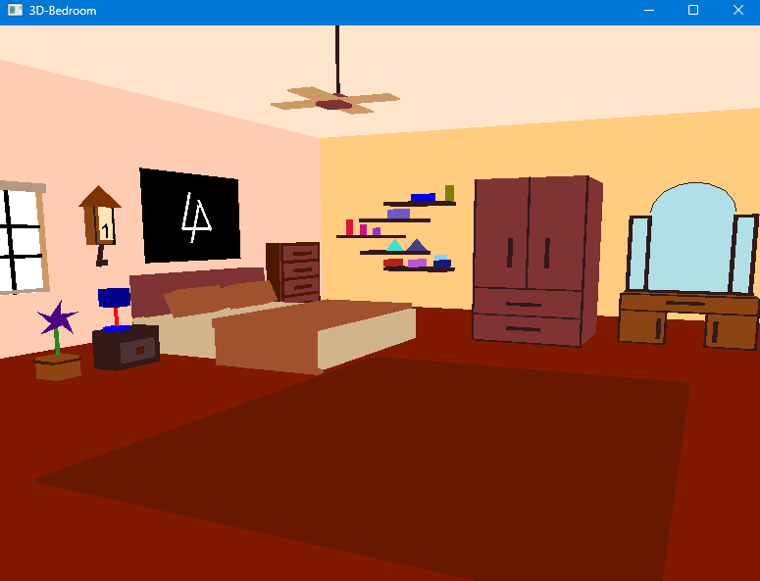- Realism: By utilizing geometric primitives and applying transformations, each component of the bedroom was crafted with attention to detail, ensuring a realistic representation.

2. Interactivity:

- Navigation: Users can seamlessly navigate through the bedroom, exploring it from various angles and perspectives. This interactivity enhances the immersive experience of the visualization.

- Element Interaction: Specific elements within the bedroom, like the fan, offer additional interactivity. Users can initiate the rotation of the fan, observing its dynamic movement.

3. Smooth Animation:

- Dynamic Elements: Elements like the swinging pendulum of the clock and the rotating blades of the fan showcased smooth and consistent animation. The rotation angles and animation speeds were fine-tuned to achieve this realism.

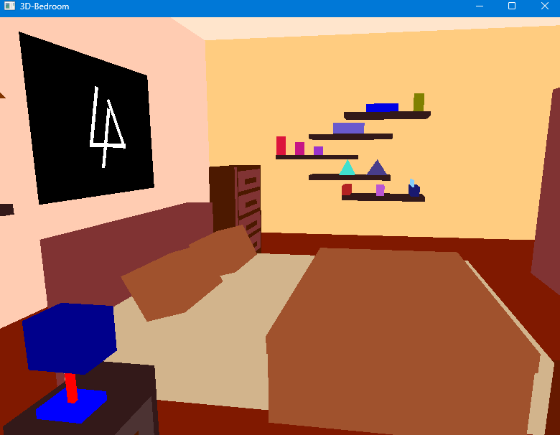

Fig:Zoom In view

4. User Feedback:

- On-screen Instructions: Upon launching the visualization, users are provided with clear on-screen instructions detailing available controls. This ensures an intuitive user experience, guiding them in navigating and interacting with the scene.

5. Performance:

- Optimized Rendering: Despite the detailed scene and dynamic elements, the project achieved optimized rendering, ensuring smooth transitions, animations, and interactions without perceptible lag or delays.

6. Scalability:

- Modular Design: The modular design of the codebase, with individual functions representing different components, ensures that the project can be easily expanded or modified in the future.

In conclusion, the 3D bedroom visualization project successfully met its objectives, delivering a detailed, interactive, and immersive environment. The results stand as a testament to the capabilities of OpenGL in crafting intricate 3D scenes and highlight the project's potential as a foundational tool for further exploration and enhancement in the domain of computer graphics.

**9. Problem Faced and Solutions**

**1. Complexity in Object Representation:**

**- Problem:** Creating intricate objects like furniture using basic geometric primitives posed challenges. Ensuring realistic proportions and details using only cubes, pyramids, and cylinders was not straightforward.

**- Solution:** By meticulously applying transformations such as scaling, rotation, and translation, and combining multiple primitives, the desired shapes and designs were achieved. Iterative refinements were made to ensure accuracy and realism.

**2. Animation Dynamics:**

**- Problem:** Achieving smooth and realistic animations for dynamic elements like the fan and pendulum proved challenging initially. Ensuring consistent speed and smooth transitions was a hurdle.

**- Solution:** By fine-tuning rotation angles, adjusting animation speeds, and employing interpolation techniques, smooth and consistent animations were realized.

**3. User Interaction and Feedback:**

**- Problem:** Integrating user controls while ensuring intuitive interactions was a challenge. Providing clear feedback and instructions without overwhelming the user was crucial.

**- Solution:** Implementing a dedicated function to handle keyboard inputs and providing clear on-screen prompts and instructions ensured an intuitive user experience. User testing was conducted to gather feedback and further refine the interactions.

**4. Performance Optimization:**

**- Problem:** As the scene grew in complexity with the addition of multiple objects and dynamic elements, there were concerns regarding rendering performance and potential lags.

**- Solution:** Efficient coding practices, optimizing rendering pipelines, and ensuring hierarchical modeling helped in achieving optimized performance. Additionally, features like back-face culling and depth testing ensured that unnecessary computations were minimized.

**5. Lighting and Shading:**

- **Problem:** Achieving realistic lighting and shading to enhance the 3D feel and depth perception of the scene was a challenge.

**- Solution:** Experimenting with multiple light sources, adjusting their positions, and using smooth shading models helped in achieving the desired lighting effects. This ensured objects were illuminated realistically, enhancing the scene's depth and aesthetics.

**6. Scalability and Code Modularity:**

**- Problem:** As the project expanded, ensuring a modular and scalable codebase became essential. Managing a growing number of functions and ensuring code clarity was crucial.

**- Solution:** Adopting a modular approach, where each component of the bedroom was represented by dedicated functions, ensured clarity and scalability. Proper code documentation and organization techniques were employed to maintain code integrity.

In retrospect, while the journey of creating the 3D bedroom visualization presented multiple challenges, each hurdle offered an opportunity for learning and refinement. Through innovative solutions and a systematic approach, the project overcame these obstacles, resulting in a detailed, interactive, and optimized 3D environment.

**10. LIMITATIONS AND FUTURE ENHANCEMENTS**

**Limitations**

**1. Lack of Textures:** The current visualization primarily relies on solid colors and shading. Real-world objects have intricate textures that add depth and realism to them.

**2. Basic Lighting Model:** While the project employs basic lighting to illuminate the bedroom, advanced lighting models that capture reflections, refractions, and shadows can significantly enhance realism.

**3. Limited Interactivity:** Currently, the user can navigate the room and interact with specific elements like the fan. However, more comprehensive interactions, such as rearranging furniture or changing color schemes, are absent.

**4. Static Environment:** Beyond the rotating fan and swinging pendulum, the environment remains largely static. Real-world rooms would have more dynamic elements, such as flowing curtains or ambient movement.

**5. Complexity in Expansion:** Due to the foundational nature of the project, adding complex objects or expanding the scene might require significant modifications to the existing codebase.

**Future Enhancements:**

**1. Texture Integration:** Introducing detailed textures for furniture, flooring, and decor can vastly improve the visualization's realism. Tools like GLSL shaders can be utilized for this purpose.

**2. Advanced Lighting and Shadows:** Implementing ray tracing or photon mapping can lead to realistic lighting effects, capturing reflections, refractions, and detailed shadows.

**3. Enhanced User Interactivity:** Features like drag-and-drop for furniture rearrangement, color palette selection for walls, and interactive object details (like opening drawers or turning on lights) can elevate the user experience.

**4. Dynamic Environment Elements:** Introducing elements like animated curtains, ambient light changes to simulate day-night cycles, or even outdoor views from windows can add depth to the visualization.

**5. Integration with VR/AR:** Taking the visualization to virtual reality or augmented reality platforms can provide an immersive experience, allowing users to "walk" through the room or even place virtual furniture in their real-world spaces.

**6. Modular Expansion:** Refining the codebase to ensure plug-and-play addition of new objects or features can make future expansions more straightforward and efficient.

In conclusion, while the current 3D bedroom visualization serves as a robust foundation, there is ample scope for enhancement and expansion. By addressing the current limitations and integrating future-forward features, the project can evolve into a comprehensive and dynamic tool for interior design, education, and exploration.

**11. CONCLUSION**

In the ever-evolving domain of computer graphics, the ability to create detailed and realistic 3D visualizations has transformed the way we perceive and interact with virtual environments. The 3D bedroom visualization project, rooted in the capabilities of OpenGL, stands as a testament to this transformative power. By meticulously crafting each component, from the grandeur of the wardrobe to the simplicity of a bedside lamp, the project offers a window into the intricacies of interior design and the potential of 3D graphics.

While the results achieved are commendable, the journey also illuminated certain limitations inherent in the foundational nature of the project. However, these limitations, rather than being deterrents, pave the way for future innovations and expansions. The horizon of possibilities, from integrating advanced lighting models to expanding user interactivity, is vast and exciting.

In conclusion, the 3D bedroom visualization project serves as a beacon of what's possible with dedication, expertise, and the right tools. It is more than just a digital representation of a room; it's a canvas of creativity, a platform for learning, and a stepping stone into the mesmerizing world of 3D graphics.

**REFERENCES**

1. Neider, Jackie, Tom Davis, and Mason Woo. "OpenGL Programming Guide". Addison-Wesley, 1993.

2. Manovich, L. "The Language of New Media". MIT press, 2001.

3. Bowman, D. et al. "3D User Interfaces: Theory and Practice". Addison Wesley Longman Publishing Co., Inc., 2004.